**Task-1:**File Navigation and Directory Structure

**Objective:** Demonstrate basic file navigation and directory structure understanding.

**Action Items:**

List all files in the home directory using a single command.

Display the absolute path of the current working directory.

Create a new directory called Practice in the home directory and navigate into it.

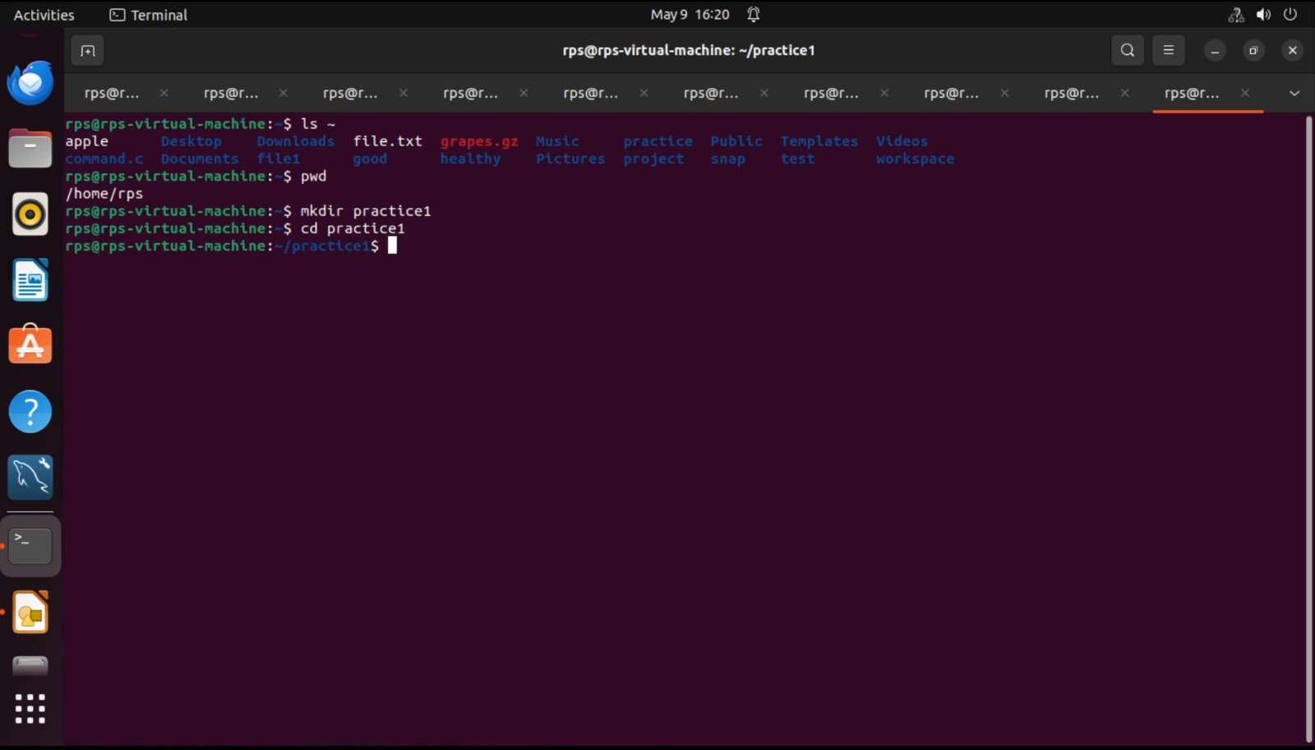

**Task-2:**File Management Commands

**Objective:** Use file management commands to organize files and directories.

**Action Items:**

In the Practice directory, create a new file called sample.txt.

Copy sample.txt to a new file called duplicate.txt.

Delete duplicate.txt using a command-line command

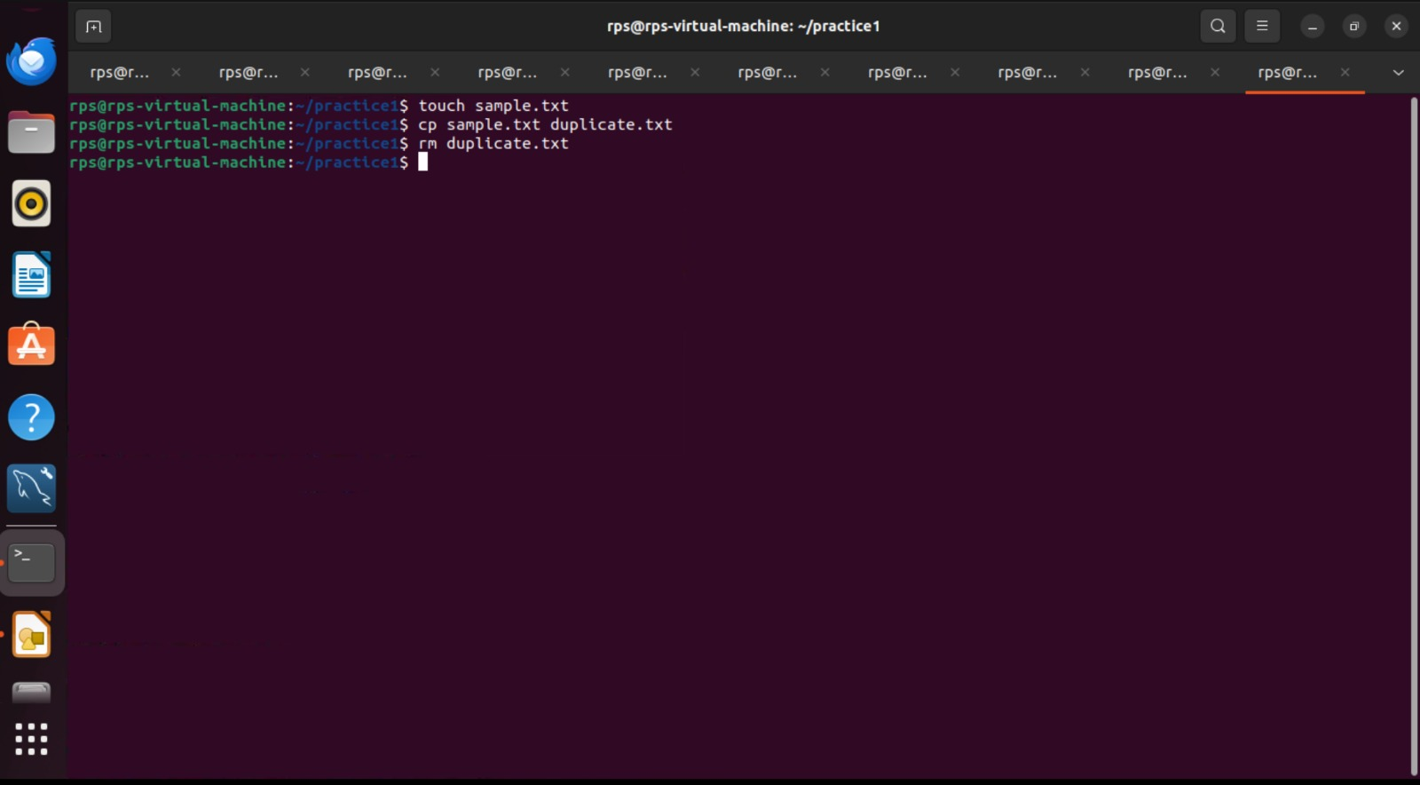

**Task-3:**Using grep to Search within Files

**Objective:** Utilize grep to search text within files.

**Action Items:**

Use grep to find all instances of the word "Linux" in the LinuxHistory.txt file.

Redirect the output to a new file called LinuxInstances.txt.

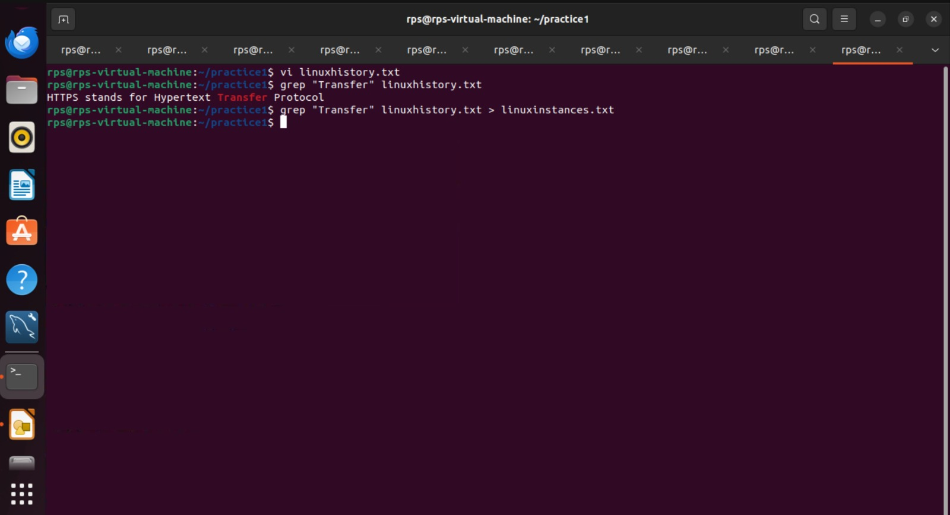

**Task-4:**Permissions and Ownership

**Objective:** Understand and modify file permissions and ownership.

**Action Items:**

View the current permissions for sample.txt.

Change the permissions to read-only for the owner and no permissions for others.

Change the ownership of LinuxHistory.txt to another user (assuming one exists).

